EECS 1011: Lab K

Mohammad Zain Al Abbideen Syed, Student ID: 218394684
November 28th, 2021

Part 1  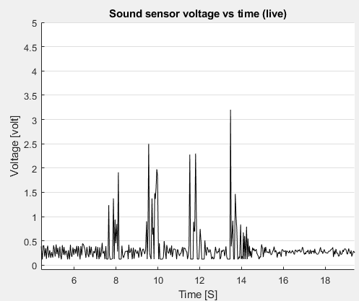 | Part 2  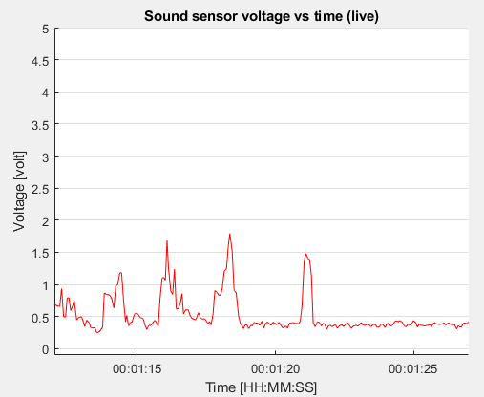
Part 3  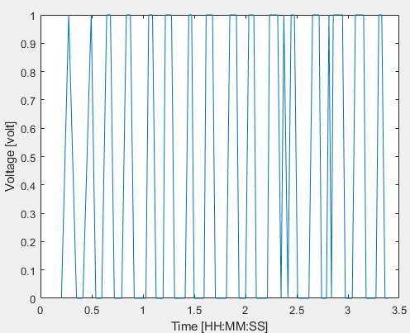 | Part 4  